To what extent can dystopia be avoided when looking for utopia?

Look at the problem with utopia when you go from fiction to reality

Bella la vita

1 none literary document

2 visual documents

1 literary text studied in class

1 literary text

The 11 Most Nightmarish Depictions of Hell in Art History :

<https://www.artsy.net/article/artsy-editorial-11-nightmarish-depictions-hell-art-history>

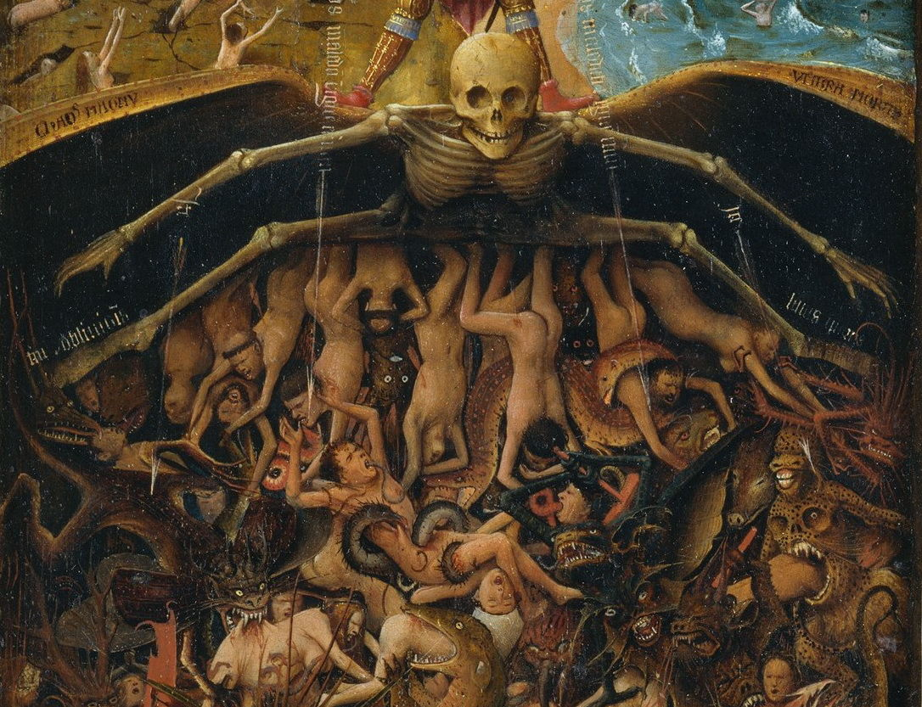

Primo levy if this is a man :

<https://www.bing.com/search?q=primo+levy+if+this+is+a+man&go=Rechercher&qs=ds&form=QBRE>

elephant man : <https://www.bing.com/search?FORM=U523DF&PC=U523&q=elephant+man>

le voyage d'Ulysse :

<https://www.bing.com/search?FORM=U523DF&PC=U523&q=le+voyage+d%27ulysse>

adam and eve :

<https://www.bing.com/search?FORM=U523DF&PC=U523&q=adam+and+eve>

They had everything, could do anything they wanted. Only restriction: it was forbidden to bite in the apple of the forbidden tree. This is what Eve does, she is tempted by what the snake told her and bites into the apple then gives it to Adam. Temptation and curiosity is in fact one of the elements that can lead to the loss of everything, such as being banned from heaven, and results in dystopia.

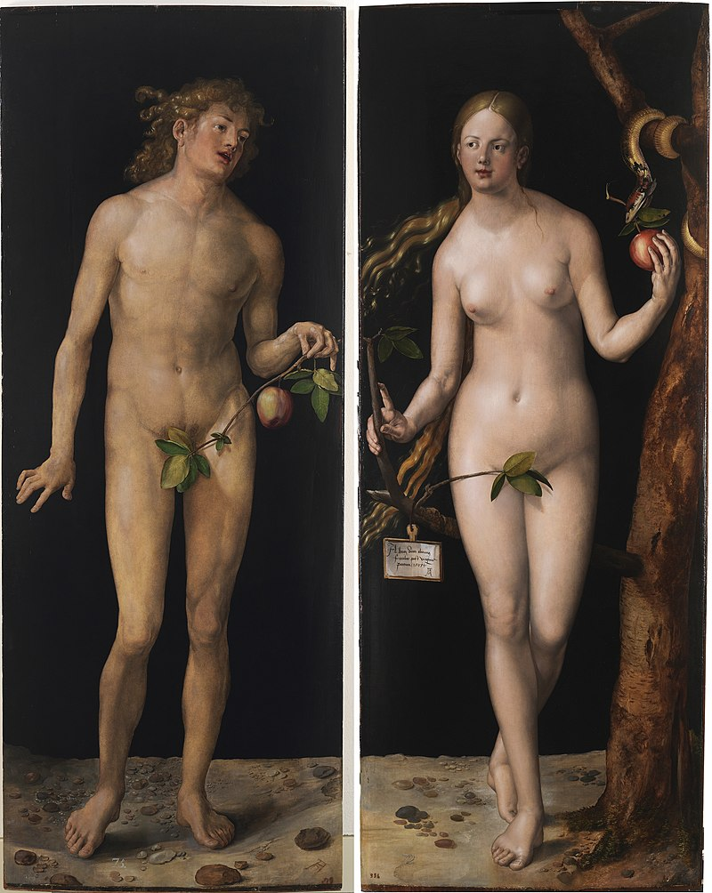

By Albrecht Dürer - Galería online del Museo del Prado de Madrid: Adán y Eva, Public Domain, <https://commons.wikimedia.org/w/index.php?curid=150385>

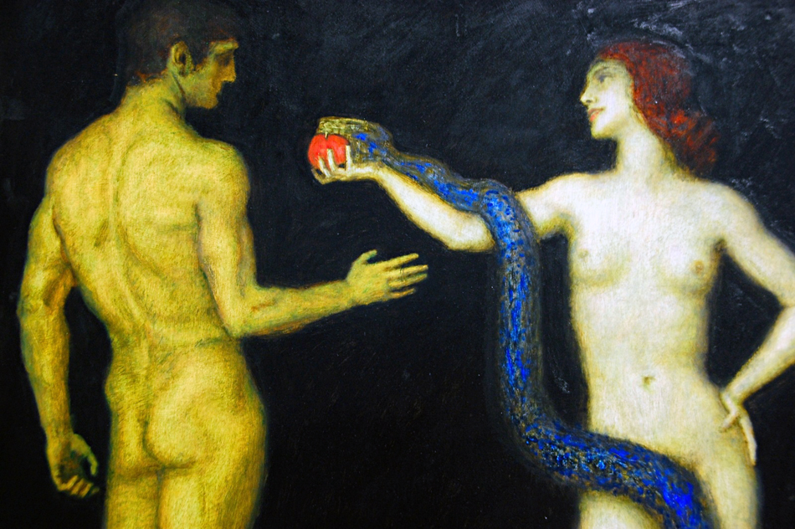

By Franz Von Stuck - Franz Von Stuck, Public Domain, <https://commons.wikimedia.org/w/index.php?curid=23032696>

animal farm : <https://www.bing.com/search?FORM=U523DF&PC=U523&q=animal+farm>

At the beginning all the animals are equal, underfed and fed up with Mr Jones, the Farmer of the barn. This situation leads to a turnover, Mr Jones, his wife and the workers of the farm are expelled by the rebellious animals. The pigs become the masters of the farm and run it. The other animals comply because they fear the return of Mr Jones. They are still underfed but feel secure because they know that the pigs are the masterminds that allowed to stop Mr Jones when he tried to take over the farm again and they are not beaten anymore. But this glimpse of utopia will soon turn back to dystopia for all the animals except for the pigs who start behaving like humans. So in some circumstances, Utopia only exists from the dystopia of the others.

French revolution :

<https://www.ecosia.org/search?q=la+r%C3%A9volution+fran%C3%A7aise&addon=chrome&addonversion=3.2.0&method=topbar>

Aim: Put in place a better government

Result: a lot of massacres, and in the end, government was as bad as what was there before.

The Truman show

He lives in a place where he can have everything he wants, but what he wanted, despite the utopian world in which he lived in was to see the outside. The utopian world in which he was, was like a prison to him.

The prisoner 1964

The prisoner is an English TV series, 17 episodes of 52 minutes, written by George Markstein and Patrick McGoohan. The story takes place int an unknown village in which an English spy, number 6, has been put after having resigned from his work. The place in which he is, looks utopian (everything is free or cheap, everybody is kind). This is how utopia is shown. Where dystopia come in is for the means of this place, extract and know what number 6 detains, there will be different test of which he will not only succeed in hiding the information from them but will event outplay the tests. Every single time number 6 tries to escape, a white floating ball will come and send him back or will be around to remind him that he cannot escape. This is why the name of the series is *The prisoner*, even if you want to escape, you will have to stick with the “Utopian world” that has been created to extract information from you.

Of mice and men :

George sees the fact that they have to go from farm to farm and will never be able to have a stable situation.

Lennie : is happy the minute there is something soft to touch, pet, …

Film :

Peter pan

Disney version : everyone is happy and will live in dream

Grims Brothers version : peter pan steal the children and kills them when they turn eighteen.

Little red ridding hood

Author : James Finn Garner

Politicaly correct bed time stories

Eats, shoots and leaves or Eats shoots and leaves.

Let’s eat grandma or let’s eat, Grandma

Execution impossible, pardon or Execution, impossible pardon

“To light a candle is to cast a shadow…” – ursula K. Le Guin, A Wizard of Earthsea

Candide , Voltaire

Cinderella

Fairy tales,

Utopia Thomas More

= Origin of the word utopia, He coined the term utopia

I Have a Dream Martin Luther King

[…] This momentous decree came as a great beacon light of hope to millions of Negro slaves who had been seared in the flames of withering injustice. It came as a joyous daybreak to end the long night of their captivity. But one hundred years later, the Negro still is not free […], the life of the Negro is still sadly crippled by the manacles of segregation and the chains of discrimination […], the Negro lives on a lonely island of poverty in the midst of a vast ocean of material prosperity […], the Negro is still languished in the corners of American society and finds himself an exile in his own land. […]

In a sense we've come to our nation's capital to cash a check. When the architects of our republic wrote the magnificent words of the Constitution and the Declaration of Independence, they were signing a promissory note to which every American was to fall heir. This note was a promise that all men, yes, black men as well as white men, would be guaranteed the "unalienable Rights" of "Life, Liberty and the pursuit of Happiness." It is obvious today that America has defaulted on this promissory note, insofar as her citizens of color are concerned. Instead of honoring this sacred obligation, America has given the Negro people a bad check, a check which has come back marked "insufficient funds."[…]

I have a dream that one day […], the sons of former slaves and the sons of former slave owners will be able to sit down together at the table of brotherhood. […]

I have a dream that […] children will one day live in a nation where they will not be judged by the color of their skin but by the content of their character. […]

I have a dream that one day, […] little black boys and black girls will be able to join hands with little white boys and white girls as sisters and brothers.

*[…]Free at last! Free at last!*

*Thank God Almighty, we are free at last!*

This is a utopian idea that has emerged in a dystopian world. Martin Luther King is a priest who is one of the main leaders of the passive fight against black segregation movement, he was not the first and was not the last. You may ask why I think this speech is utopic. I will answer that black segregation and racism has been around for decades and is still accurate in America. Where the passive fight has had an impact is that it reduced and almost deleted racial segregation. It deleted the segregation imposed by the government, such as legally outlawing segregation with the Civil Rights Act of 1964 or taking down the “whites only” signs from water fountains, bathrooms, and restaurant counters. But I would say that the original imagined utopian world has shifted, it isn’t the government imposing this separation but ourselves. For example, in America there is a lack and a white America because each race wanted to stay with their own kind. So, this is an example where Utopia has succeeded in being installed and remain but it has changed and could be considered as a form of self-inflicted dystopia in some cases.

The Tempest William Shakespeare

Pandora’s box

Pandora’s box takes place in a utopian world, where everything is fine, everybody is happy and there are no diseases, there is no hate, only positive emotions (being sad is in it to) rule the world, util, the gods gave Pandora, the first mortal women to come to the world and with Pandora the Zeus gave her a special box in which he put all the forces of evil and suffering he had created. With this box he told her that it was to remain closed and shouldn’t be opened in any circumstances. But the Greek goods wanted it to be opened and so, Zeus gifted Pandora the trait of curiosity. Combined with Aphrodite gift, feeling deep emotions, this was enough to open the box and release its content into the world. In this box, there was only one positive force, it hadn’t had time to come out after that Pandora had shut the box, but without it, the world is lost, this force was hope. It is an essential force that helps us through hard times. This is why I think that without hope we would live in constant dystopia because Utopia can never be complete, and it is generally short. This is why hope allows us to live through life having an idea, a glimpse, a wonder about how a utopian world can be made, lived in.